**Course: Business Analysis and Assessments**

**Assignment 3 – Executive Dashboards**

|  |  |
| --- | --- |
| Submitted By: | Tanya Tyagi |
| Submission Date: | 16/04/2025 |
| Student ID: | 100952705 |

Contents

1. Document Overview 3

2. Data Analysis 3

2.1. Data Dictionary 3

2.2. Data Quality 4

2.2.1. Date field 4

2.2.2. Market/Province/City consistency of stores 4

2.2.3. Calculated field consistencies 4

2.2.4. Store#, Date, Product uniqueness 4

3. Data Scope 4

3.1.1. KPQs: 5

4. Recommendations & conlcusions 5

4.1. Recommendations 5

4.2. Conclusions 6

5. Executive Dashboard 7

# Document Overview

This executive report analyzes Coffee Cup’s whole operational data set from Canadian retail stores during 2023 to 2024. The objective is to convert The Coffee Cup’s initial sales data into valuable strategic information through Power BI so management can make optimal business decisions. The specialty beverage market demands fast-moving visual tools that track regional operating results together with product patterns and profit levels and budget performance connections in real time for management decision-making. This report reveals data quality details and it presents strategic recommendations for future years starting in 2025.

# Data Analysis

This part defines the structural elements of the raw dataset along with its capabilities for business intelligence and performance assessment. The 4,248 entries of the dataset present sales information with budget assessment and product information from different regions. Due to its combination of numeric and categorical elements with date-based data structures the database meets requirements to create dashboard visualizations.

## Data Dictionary

|  |  |  |
| --- | --- | --- |
| Sr. No. | Column Name | Description |
| 1. | Profit | The calculation produces net earnings by removing all related costs from the sales revenue. |
| 2. | Margin | Shows the profitability as a percentage of sales. Divide profit by sales revenue then multiply by 100 to obtain the percentage. |
| 3. | Sales | The expressed worth of all merchandise sold represents the generated sales value. |
| 4. | Cost of Goods Sold | Business operations pay for all costs related to manufacturing or acquiring sold products. |
| 5. | Total Expenses | All costs that occur during operations plus operating overheads with the exclusion of costs of goods. |
| 6. | Marketing | The funds spent by the store to conduct its marketing initiatives and campaign events. |
| 7. | Inventory | The number of product units available at each store location at the time of data capture. |
| 8. | Budget Profit | Business forecast indicates the estimated profit for a particular time period. |
| 9. | Budget Margin | The company uses projected margin rates which stem from expected sales figures and profit predictions. |
| 10. | Budget Sales | The retail establishment sets sales revenue figures considered as achievable targets. |
| 11. | Budget COGS | The budgeted sales requirements have specific cost expectations. |
| 12. | Date | The transaction or recording date comes with its information presented in a day/month/year pattern. |
| 13. | Market | Stores belong to general geographical market groupings which are organized by Atlantic and Central and West regions. |
| 14. | Province | The retail store operates from a definite Canadian provincial area. |
| 15. | City | Date reveals the urban area where this particular retail store located performed the transaction. |
| 16. | Store# | A unique reference code serves to distinguish every store throughout different regional areas. |
| 17. | Market Size | Categorical classification of the market size – Small Market or Major Market. |
| 18. | Product Type | Broad classification of the products (e.g., Coffee, Tea, Herbal Tea, Espresso). |
| 19. | Product | The specific item name under the product type that was sold included Lemon Tea and Caffe Mocha. |
| 20. | Type | Further categorization of the product, such as Regular or Decaf. |

Table 2.1 Data dictionary for Coffee Cup Data

## Data Quality

### Date field

* The Date field exists as text with format DD/MM/YYYY while it should be stored as a proper date format.
* An effective quarter/month/year sort requires proper conversion before implementation.
* Standardization is necessary to analyze time-based trends in any system.
* Preprocessing should convert the Date field to datetime format for achieving accurate dashboard results.

### Market/Province/City consistency of stores

* The Canadian geographic regions listed in Provinces and Cities section correspond to their actual national locations.
* The organizational scheme that divides the market into West, Central and Atlantic segments fits the province-based data structure.
* All data fields showed an absence of null entries in addition to being free from format discrepancies.
* Future record validation needs a database which checks geographic correctness.

### Calculated field consistencies

* The computation of margin values remains uniform by multiplying profit divided by sales followed by a multiplication by one hundred.
* The analysis shows no severe errors yet few profit margin values suggest unprofitable product units.
* The alignment between Budget and Actual figures seems plausible but needed ratio analysis for complete assurance.
* The comparison of Inventory and Marketing costs is possible between different stores because these fields have direct comparability.

### Store#, Date, Product uniqueness

* Analytical processing at the transaction level is possible through the combination of Store# with Date and Product fields.
* The database has no entries that repeat themselves after applying this combined key.
* A time-based examination of products at the store level becomes possible with this system.
* The visual elements in Power BI achieve precise aggregation and filtering functions.

# Data Scope

The data scope specifies both the full range and specific restrictions which influence the dataset analysis. The Coffee Cup dataset presents extensive performance information about operational activities and regional activities and product performance across the fiscal years of January 2023 to December 2024. The dataset encompasses information from multiple Canadian provinces and contains business records exceeding 4,000 from diverse store locations.

### KPQs:

**What the data can answer:**

* The regions where maximum business revenue and earnings occur?
* The Stock-Keeping unit’s along with their accompanying product types that produce the largest impact on profitability?
* Stores are they achieving their fixed forecasts or are they unable to reach them?
* Sales performance follows what pace compared to budgeted figures each month and yearly?

**What the data cannot answer:**

* Do customers feel satisfied with the store purchase experience?
* How does the customer base split into different population groups?
* How many people stopped by each shop for business (resource flow)?
* Practices of promotional advertising and seasonal discounting have what level of business impact?

**Recommended 2025 data additions:**

* Customer satisfaction surveys (NPS scores)
* Footfall sensors per store
* Demographics from loyalty programs
* Although the data shows promotional periods it lacks information on specific sales attributed to those periods.

# Recommendations & conlcusions

## Recommendations

* **Focus on High-Margin Products:** The company should establish a campaign focusing on Colombian coffee and Herbal Teas and top-performing inventory products across every shop. The business achieves maximum value from products showing both high margins and profitable share results.
* **Optimize Low-Budget Markets:** The stores in small markets of PEI and New Brunswick would benefit from marketing or promotional initiatives to grow their potential.
* **Standardize Data Entry:** The entire entry process must conform to meticulous date standards together with product rules and financial formatting standards to minimize cleanup requirements.
* **Track Promotions & Campaigns:** The evaluation of campaign success throughout different provinces needs results from promotional initiatives and the rise of store sales recorded during these times.

## Conclusions

* **Strong Sales in Ontario & BC:** The provinces generate maximum sales and achieve highest profitability numbers in the market. The organization should direct its future market growth toward Ontario and British Columbia.
* **Margin Management Required:** Several entries show negative margins. Monitoring cost structures alongside loss-making products requires immediate attention as an important step.
* **Data Quality is High:** The usability of interactive dashboards depends on data that maintains high levels of cleanliness and structure. Additional customer information enables organizations to develop more individualized methods for marketing and strategy development.
* **Strategic Dashboarding Is Valuable:** Throughout its operation the Power BI dashboard provides essential performance indicators and trends to senior executives which satisfies the project requirements.

# Executive Dashboard

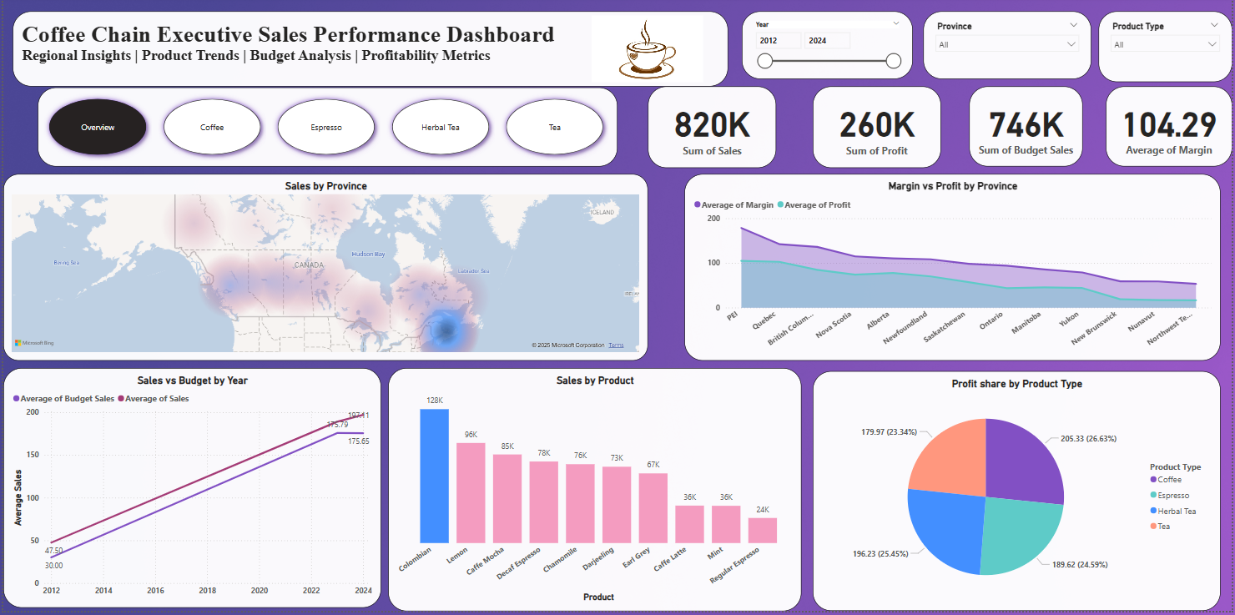

You can access the POWER BI dashboard using the .pbix file submitted with this report.